Set the swapi entry on each node to 167.118.112.191. This is the address of the load balancer for the swResObj. On each of the nodes (linux servers) cd to /etc/. Use vi to edit the hosts file.

sudo vi hosts

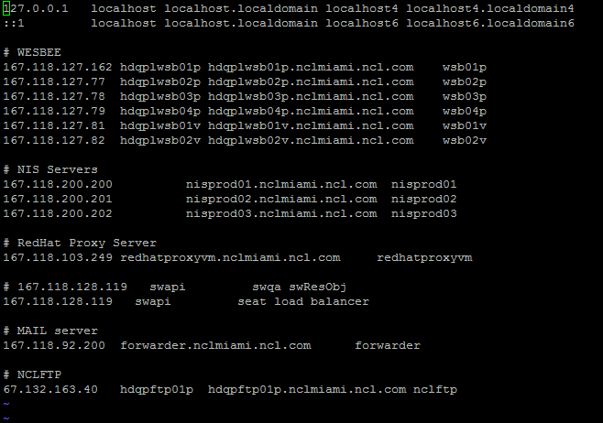

Edit swapi entry to 167.118.112.191

